Week 4 Pandas Homework

**Heroes of Pymoli**

Data Analysis of :

* General Totals
* Gender
* Age
* Purchases

Purchasing Analysis Total

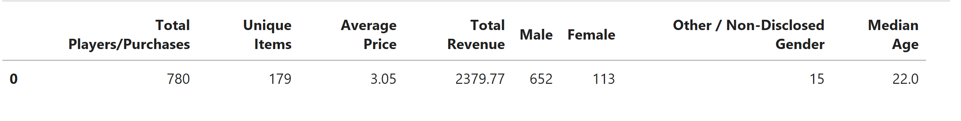

From the data we can see:

* 780 payers have made purchase.
* 179 of those purchases were for unique items.
* The average purchase price was $3.05
* Total Revenue from this $2379.77
* Men made up the majority of purchases at 652 out of 780. Women were almost 6 times less at 113 total purchases.
* The median age of players who purchases an item was 22 years of age.

Gender Demographics

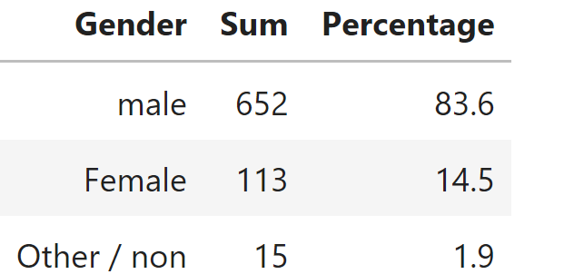

From the data we can see:

* Men make up more than 80% of the purchasing population.
* Women are under 15% as the figure is already rounded.

Purchasing Analysis by Gender

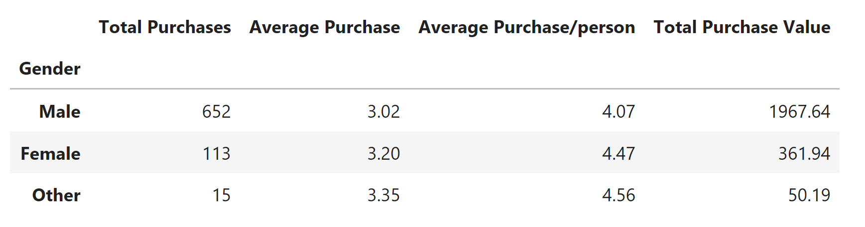

From the data we can see:

* Though male players out number female players female players spend more on average than male players by $.18 and the individual female player spend $.40 more than individual males on average.
* Non-disclosure or non-conforming gender types spend more on average than both identified gendered.
* Despite average trends in spending being higher in women and in other/non disclosed men have sheer volume of purchases which accounts for 80% of the purchase value.

Age Demographics and Purchase Analysis

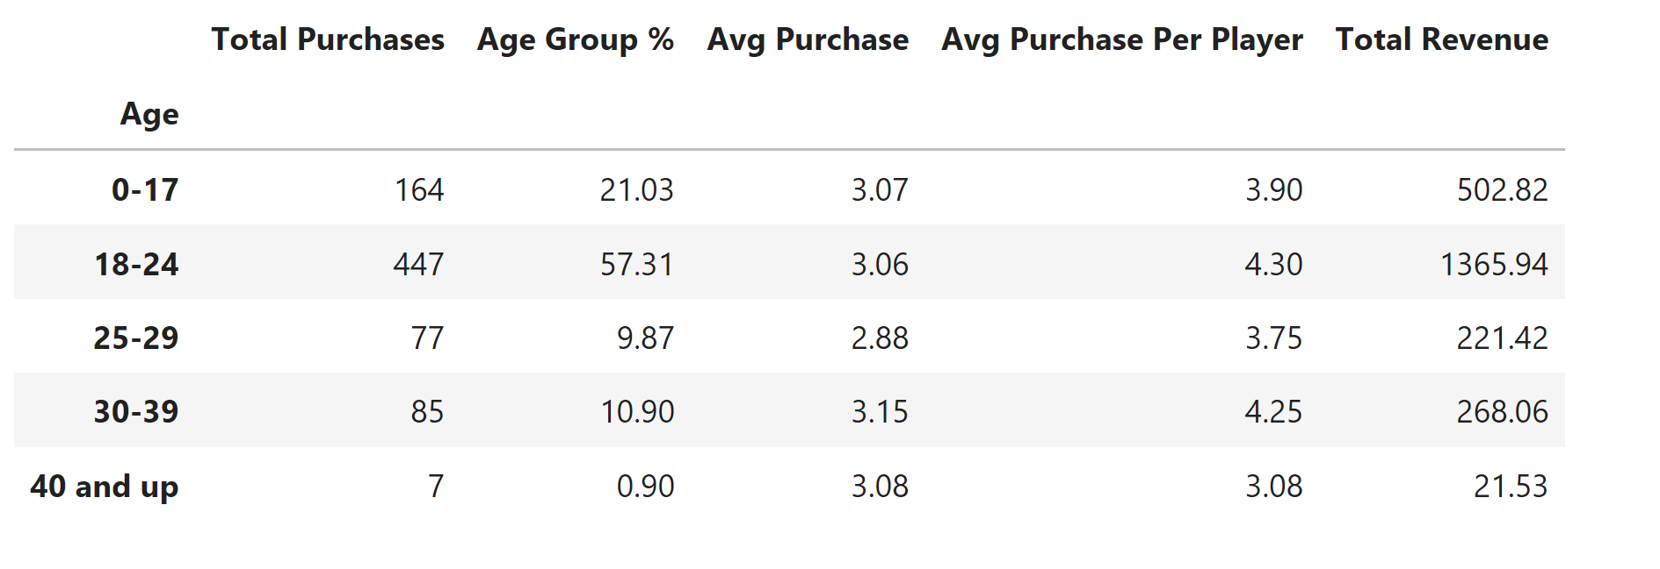

From the data we can see:

* The majority of players who have purchased items are aged between 18-24 years of age. Accounting for over 57% of the purchases.
* Even though the 18-24 crowd spends more individually than any other age group the 30-39 age group spent more on average followed by the 40 and up age group.

Top Spenders

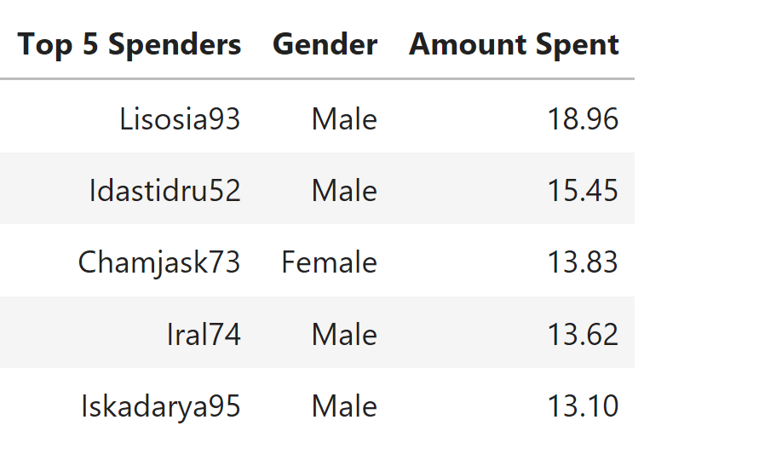

From the data we can see:

* Male players are more likely to make multiple purchases and spend more money on in game items.

Most Observable Trends

1. Men make up the majority of players in Heroes of Pymoli and are willing to spend more money more frequently.
2. Despite the spending habits of the 30-39 and 40 and up age groups the 18-24 age group makes up the majority of the games players accounting for over 80%.
3. Although the 18-24 crowd comprises the majority of the players who made purchases the 30-39 and 40 and up age groups are both able to spend greater sums of money.